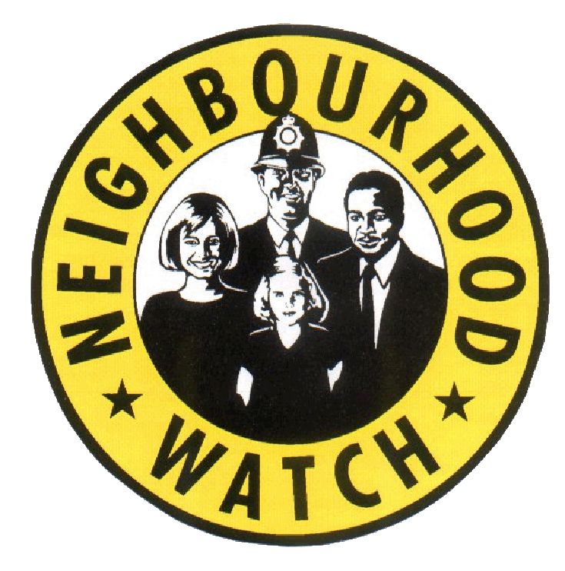

EAST RIDING NEIGHBOURHOOD WATCH

August 2019
Firstly I would like to say thank you and welcome to the new groups that have signed up since 1st May 2019:
Brereton Close Molescroft Beverley, Bewholme Village Parish Council, Gilberdyke Village Parish Council, West End Falls Nafferton, Rawcliffe and Rawcliffe Bridge Parish Council, Eastrington Parish Council, Easington Dimlington Bungalows, Rawcliffe Station Road, Pocklington Overend Avenue, Pocklington Tweengates Close, Stamford Hill Parish Council, Ingle Court Market Weighton, Great Givendale Village, Bridlington Wellington Road West Bridlington, Bridlington Ebor House, Bridlington Ferndale Terrace, Easington The Brambles, Beverley Shorthill Croft, Hedon Town, Burton Pidsea Barley Garth, Burton Pidsea Gemel Road. Hornsea Town, South Cave The Meadows
Neighbourhood Watch Event Update:
Here are some interesting statistics from the event workshop:
Pre Workshop Questionnaires
22% of coordinators said they did know who their ASB Officer was
44% had a clear understanding of ASB prior to the event
56% had some understanding ASB prior to the event
Interesting note: 66% of those who had the best understanding of ASB are members of a cluster/area NHW group
Post Workshop Questionnaires
86% said they knew who their ASB Officer is after the event
91% of attendees felt they would now like to get involved in anti ASB events

Cluster Groups:
80% of those who said they were not aware of Crime stoppers or My Community Alert are not part of a cluster/area group. This definitely high lights the benefits of working together in larger area groups.
Now there is more acknowledgement for the support of area groups and there is a more even distribution of NHW groups across the East Riding we are in a better position to offer you and your area the support you need to come together as area/cluster groups and to meet myself and your local police at least twice a year.
Groups in the area that are already set up are:
Pocklington and Market Weighton Crime Prevention Panel (this group is inclusive of all the villages and hamlets in the North West of the county
Beverley and Rural NHW Panel – Including surrounding villages
Bridlington Town NHW Group
Withernsea Town and Rural NHW Group
Goole Crime Prevention Panel
If you are not part of one of the groups above and would like more information on setting up a an area group let me know.
All other feedback from the workshop is being collated and discussed with local policing teams to see how we can improve communications and get you more involved. I will send out an action plan once that has been agreed.
Friends of Scams Awareness Training
Nat West are now offering scam awareness training in partnership with East Riding Voluntary Action Service (ERVAS) which means they can now provide the facilities as well as the training. There was training in Withernsea on 25th July and below are two training events coming up for anyone who would like to attend. I will share more with you as they become available. Please use the links to register your place.
Pocklington Tuesday 13th August
Pocklington - https://www.eventbrite.co.uk/e/natwest-friends-against-scams-digital-safety-training-tickets-62041898990
Driffield Monday 7th October
https://www.eventbrite.co.uk/e/natwest-friends-against-scams-digital-safety-training-tickets-65516598911

Alternatively please let me know if you have a group of interested residents as they would be happy to set courses up on demand. if you have groups of interested residents/coordinators let me know and I will liaise with them.
Social Prescribing
You will be hearing more from me about social prescribing in the coming months in the meantime here is an overview.
Social Prescribing Link Workers are based in all ERY GP practices for a minimum of one day per week, they work with people to identify what matters to them in relation to their health and wellbeing by complimenting existing treatment and where appropriate helping people to make lifestyle changes that impact positively on their physical, mental or emotional health. They can support, advise or refer people to a range of services and for those in the more isolated areas they will arrange for the Connectors to help you make those connections at a local level where possible. Additionally, the Build team can help and support people or groups who wish to set up a group, volunteer or become active in their communities.
With over 3,000 referrals to date they have assisted people with a range of issues a few of which are below, and remember it’s free, confidential and friendly.
One or more physical long term conditions/Smoking/Drug and Alcohol Awareness/Weight Management/Physical Activity/Social Isolation/Emotional Wellbeing (low level stress and anxiety)/Carer support/Welfare support/Sexual Health/Relationships
How do I seek the support of a Link worker?
You can be referred by a host of people and agencies including your GP or practice staff but you can also contact them direct using the information below.
Call: 0800 9177752
Email: HNF-TR.Healthtrainers@nhs.net
Why not follow us: @healthtrainers1

Action Fraud (Information via My Community Alert)
HMRC Alert
What you need to know
• Action Fraud has experienced an increase in the reporting of malicious calls and voicemails, to members of the public purporting to be from Her Majesty’s Revenue & Customs (HMRC).
• Fraudsters are spoofing genuine HMRC telephone numbers to deceive their victims over the phone. The fraudsters state that as a result of the victim’s non-payment of tax or other duty, the victim is liable for prosecution or other legal proceedings in order to settle the balance. The fraudsters suggest victims can avoid this, by arranging payment to be made immediately by methods such as bank transfer or by purchasing iTunes gift cards.
• If the victim is hesitant or refuses to comply, the suspect makes a threat such as immediate arrest, sending bailiffs to the victim’s address or, in some cases, deportation.
• Often, the period for which the tax is allegedly due is distant enough to guarantee the victim will have little, if any, paperwork or ability to verify the claims. Once the money is paid the suspects sever all contact with the victim.
• In genuine cases, HMRC will initially make direct contact with you via post/letter and potentially follow up that letter with a phone call at a later date.
• If HMRC contact you via telephone they will quote the reference number on the initial letter you should have received. HMRC will not discuss something you are not already aware of, like a tax investigation, and will NOT demand immediate payment.
It is vital that the public exercise caution when receiving messages or telephone calls of this nature.
What you need to do:
What you need doesn’t mean they are genuine. Instead, contact the company directly using trusted methods such as a known email address or phone number.
• Legitimate organisations wouldn’t ask you to pay taxes, bills or fees using an iTunes gift card, or any other type of voucher. If you’re contacted by anyone that asks you to do this, you’re likely the target of a scam
• Don’t be rushed or pressured into making a decision. Under no circumstances would a genuine bank or some other trusted organisation force you to make a financial transaction on the spot.
• Report Phishing attempts. If you receive a call, text or email of this nature and have not lost money, you can report this as phishing to Action Fraud
• Always question unsolicited requests for your personal or financial information. Just because someone knows your basic details (such as your name and contact details), it doesn’t mean they are genuine. Instead, contact the company directly using trusted methods such as a known email address or phone number.
• Legitimate organisations wouldn’t ask you to pay taxes, bills or fees using an iTunes gift card, or any other type of voucher. If you’re contacted by anyone that asks you to do this, you’re likely the target of a scam
• Don’t be rushed or pressured into making a decision. Under no circumstances would a genuine bank or some other trusted organisation force you to make a financial transaction on the spot.
• Report Phishing attempts. If you receive a call, text or email of this nature and have not lost money, you can report this as phishing to Action Fraud on 0300 123 2040
Regular Features
CRIMESTOPPERS:
While improvements are being made to the non-emergency number please use Crime stoppers to report criminal activity on 0800 555 111. However, if you require urgent police attention call 999.
MY COMMUNITY ALERT:
Sign up to the new free messaging system operated by Humberside Police and keep updated with what is happening in your local area. For more information and to register go to:
www.mycommunityalert.co.uk
CRIME PREVENTION SHOP:
A reminder that Hull Neighbourhood Networks have an on line shop where you can buy all sorts of crime prevention items.
Here’s the link
https://www.nnetwork.org.uk/shop/
There are a number of items available including card protectors which will stop fraud by blocking access to the magnetic strip on your card which if accessed can result in your card details being duplicated.
we sell them at a £1.00 each!
The coupon code is ERMEMBER so that the groups in the East Riding can get the discount. Just add the coupon code when prompted and the discount will be taken off,
The current discount is £1.00 per item and currently £5.00 off the cycle lock. We have set up postage with Hermes but they can offer collection from their base at Zeal’s Garth Hull free of charge.
The next NHW Newsletter will be sent out mid October so the deadline for coordinator contributions will be Monday 7th October 2019

Maureen Yates Community and Crime Reduction Resilience Officer
Housing and Public Protection, East Riding of Yorkshire Council, County Hall, Cross Street, Beverley
HU17 9BA
Telephone: 01482 391013
Mobile: 07899 061213
Maureen.yates@eastriding.gcsx.gov.uk

